**Project Design Phase-II**

**Data Flow Diagram & User Stories**

| Date | 12 October 2022 |
| --- | --- |
| Team ID | PNT2022TMID19343 |
| Project Name | IoT Based Safety Gadget for Child Safety Monitoring & Notification |
| Maximum Marks | 4 Marks |

**Data Flow Diagrams:**

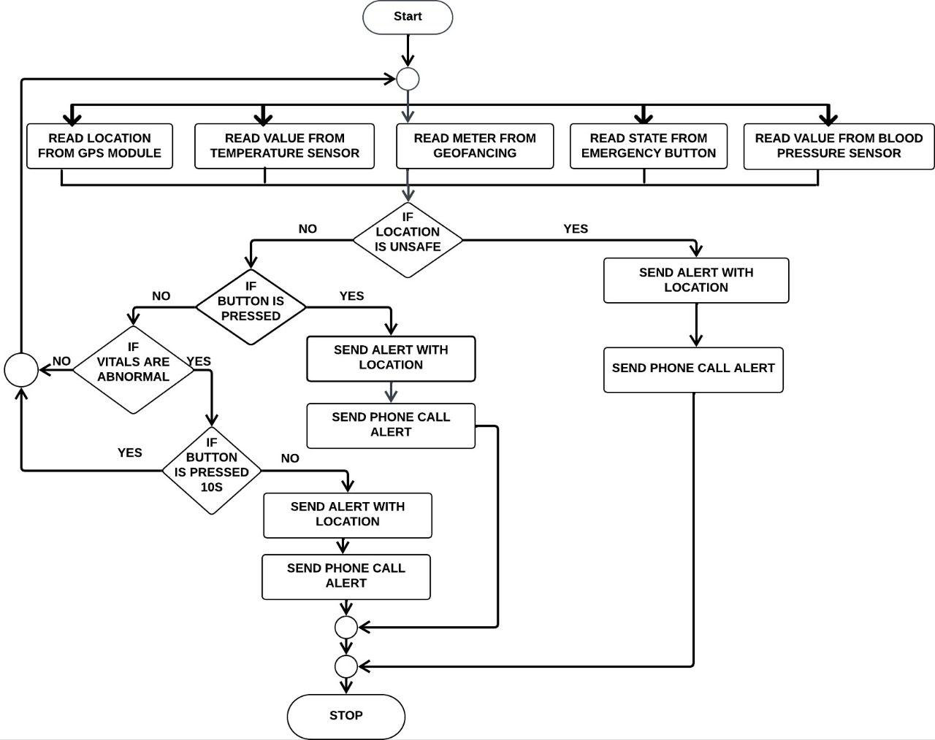

**User Stories**

| **User Type** | **Functional Requirement (Epic)** | **User Story Number** | **User Story / Task** | **Acceptance criteria** | **Priority** | **Release** |
| --- | --- | --- | --- | --- | --- | --- |
| Customer (Web user) | Authorize | USN-1 | As a user, I can register for the application through Gmail | I can register through Gmail | High | Sprint- 1 |
| Customer (Web user) | Confirmation | USN-2 | As a user, I will receive confirmation email once I have registered for the application | I can receive confirmation email & click confirm | High | Sprint-2 |
| Customer (Web user) | Dashboard | USN-3 | As a user, I can get alert notification, when the child moves out of the geofence | I can get the alert about the child | Medium | Sprint- 1 |
| Customer (Web user) | Notification | USN-4 | As a user, I can track the child’s location | I can track location | High | Sprint- 2 |
| Administrator | Service | USN-5 | As a user, I will get a call incase of emergency | I will receive a phone call | High | Sprint- 3 |
| Customer (Web user) | Logout | USN-6 | As a user, I can logout of this application | I can logout | Low | Sprint- 4 |